MyLogins Separated user request

Mylogins request # **209293592**

1. The assigned requests are displayed in Mylogins under Provisioners > Assigned Queue

MyLogins url :- <https://mylogins.cso.att.com/index.cfm>

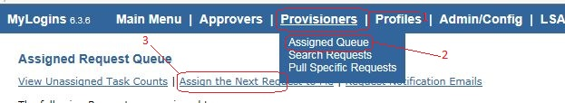

Access the requests using 1 > 2 , in case the request is not visible click on Assign the next request to me (3) and if it has not been picked by one of the provisioners then it will reflect in your list.

1. You can also access a request by searching for it using the request number and it will provide associated information such as whom it has been assigned to, the user IDs, the login names etc.

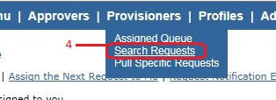

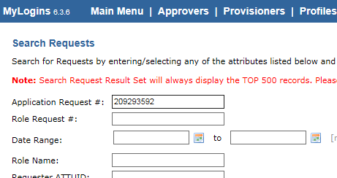

After populating the application request number click on **Search**

If the request has been approved by the approver it will be displayed as approved and can be pulled in your assigned list and subsequently worked

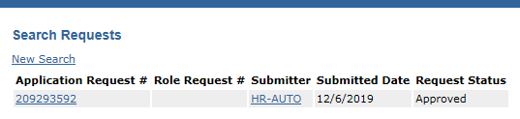

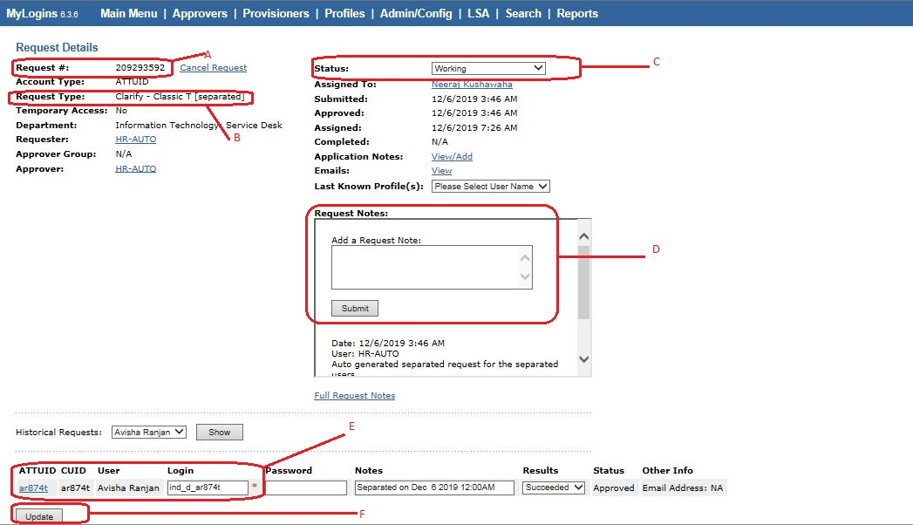

A - Request number is listed here

B – Request type is listed here (separated, delete, PR_DELETE, Add, Change)

C – Status of the request, after completing the request change it to completed using the drop down list, then click submit. DO NOT click submit before ensuring the changes have been made.

D – Notes have to made here throughout the process of resolution

E – Details of user such as attuid, Name, Clarify Login name are listed here which are impertinent for resolution.

F – After conclusion click on Update to make the changes permanent.

1. Moving on to the sample request, here we can see in the request type that it is a separated request.

A separated request is logged when a user has left the organization, it is also indicated in Notes near E.

1. To fulfil a separated request the listed users need to be deactivated in Clarify. To make the requested change you need to log into Clarify Classic T GUI.
2. Click on Select

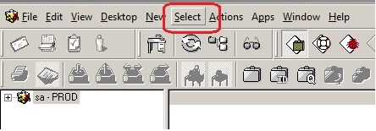

Click on employees to reach the following window

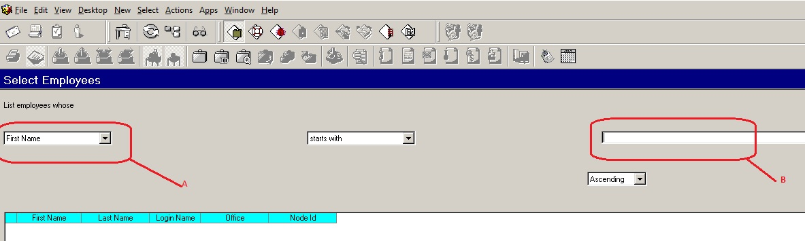

A – using drop down select login name, or use other filters such as first name, last name, office/site etc.

B – populate the value in B and click enter to (login name used in this example) fetch the details below.

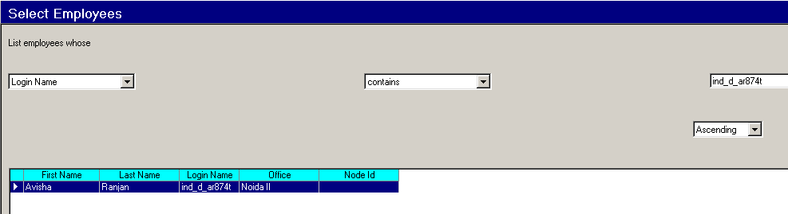

1. Double click on the fetched field to open the user details.

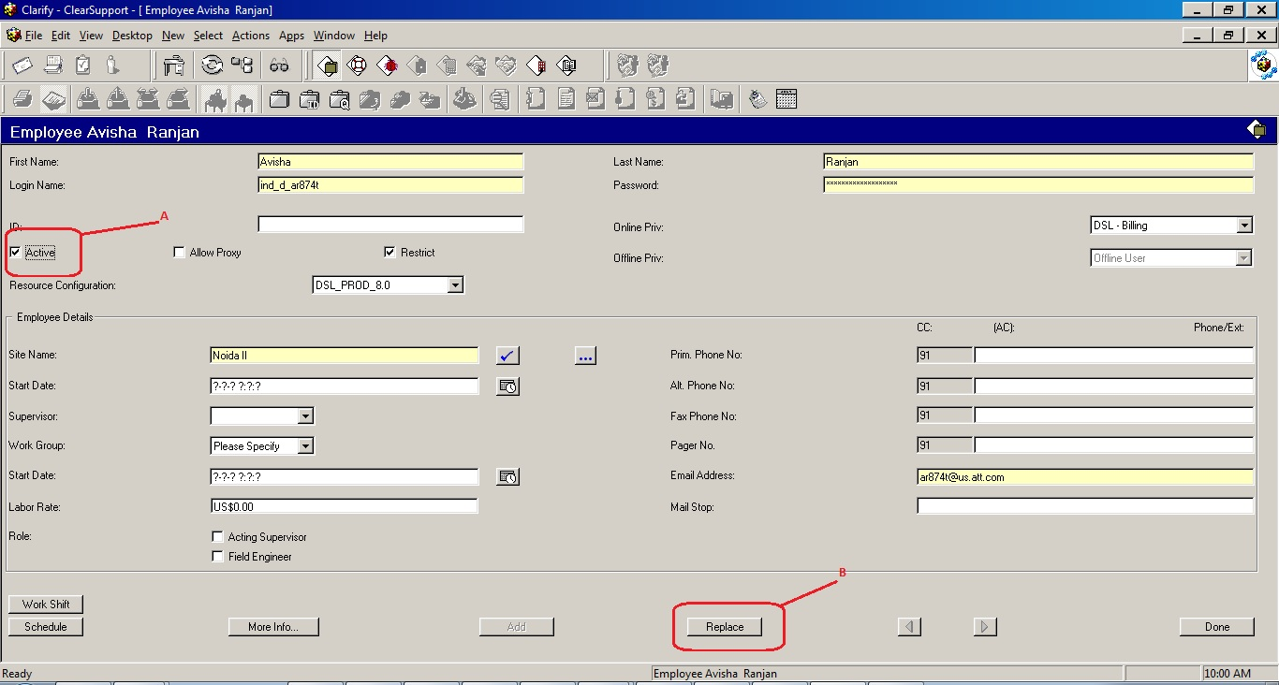

1. Uncheck the active checkbox.
2. Click replace to successfully deactivate the user
3. After deactivating the user, write down your notes in the MyLogins request notes then submit, change the status to **completed** and then click on **update.**

